**CN LAB-3 TASK**

**S.M.HASSAN ALI**

**K20-1052**

**Q1.**

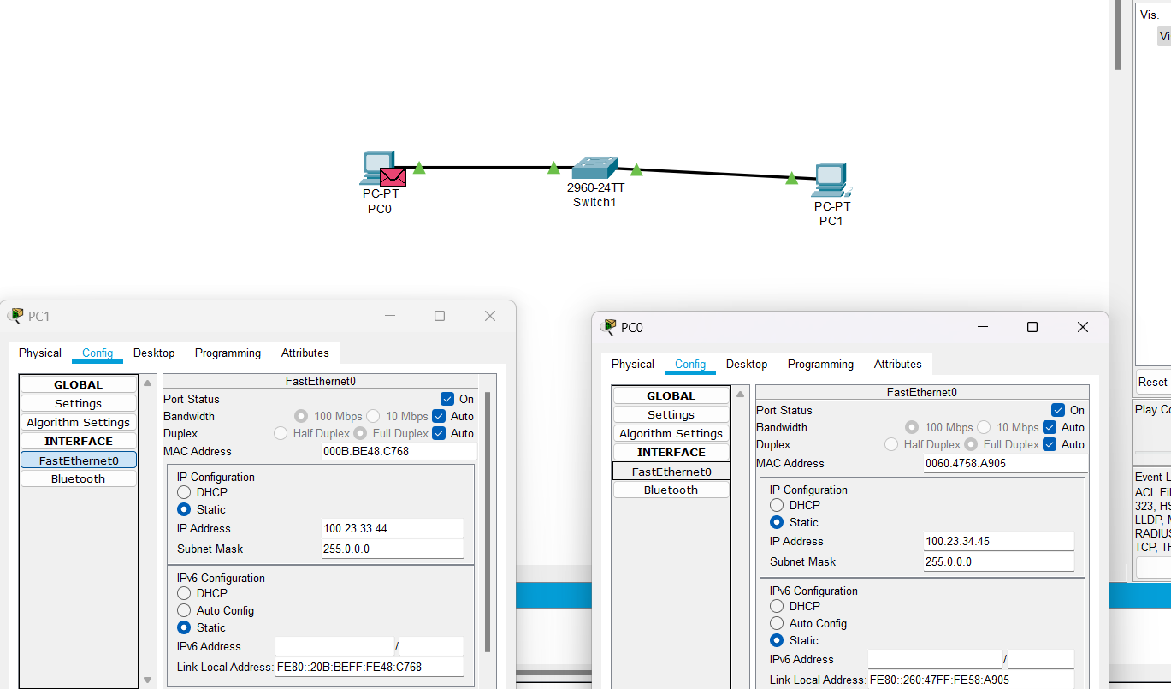

Ping the ip to check the response

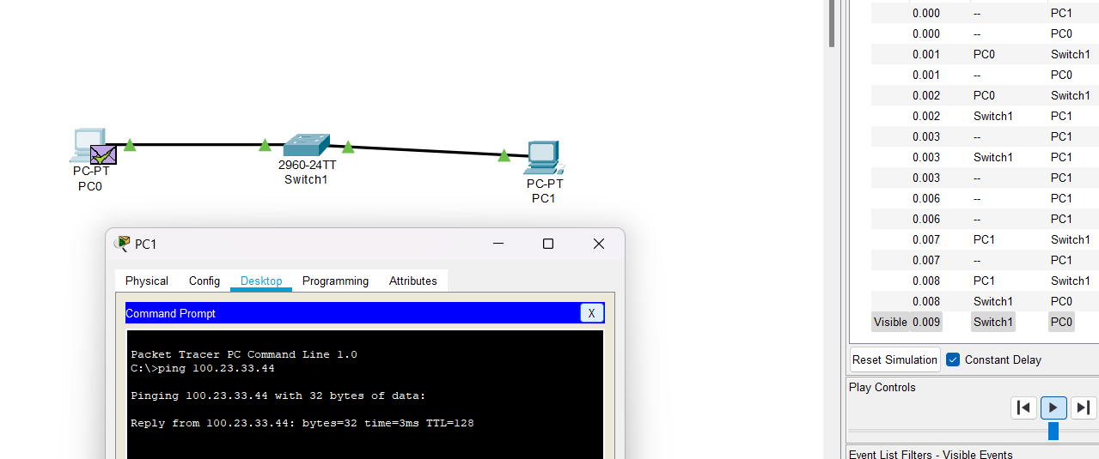

**Q2.**

Crossover copper cable is used because it enables one to establish a direct connection between two computing devices using Ethernet ports.

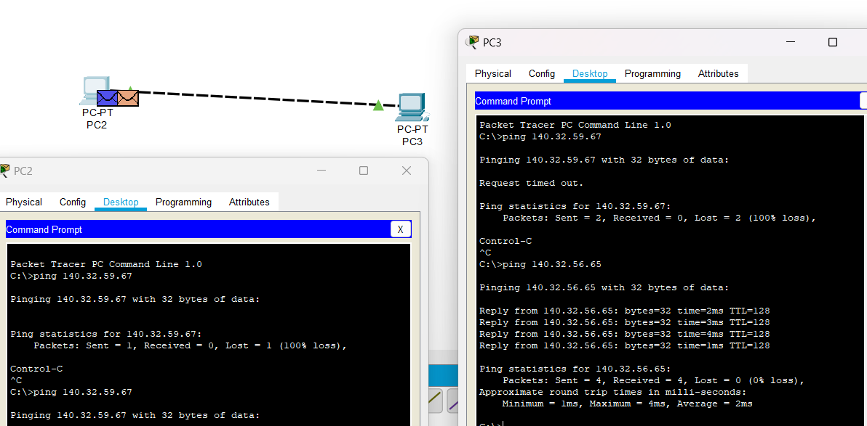

**Q4.**

PC 4,5,6,7 are connected through switches and packets are being forwarded. Switch will only uni-cast (while hub is not intelligent enough so it broadcast) the packet being sent from PC4 to PC7.

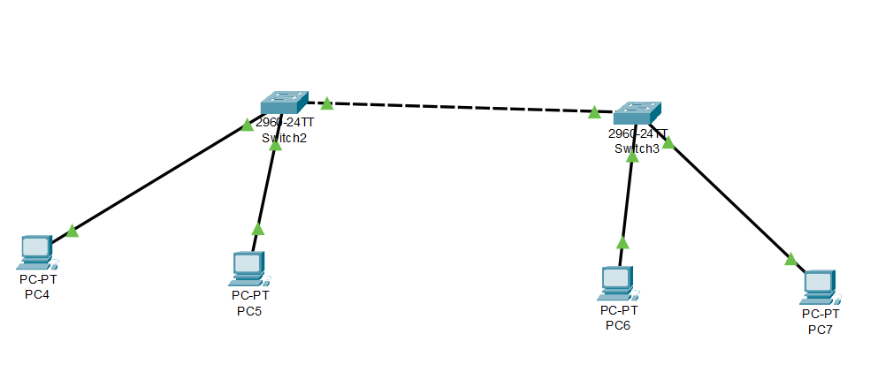

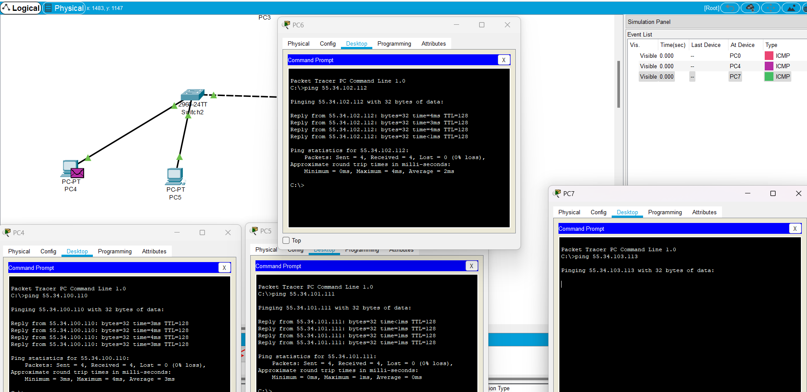

**ADDRESS CLASS IDENTIFICATION:**

**CLASS A**

**CLASS B**

**CLASS C**

**CLASS B**

**CLASS C**

**CLASS A**

**CLASS C**

**CLASS D**

**CLASS B**

**CLASS A**

**CLASS E**

**CLASS C**

**NETWORK & HOST IDENTIFICATION:**

**[] = NETWORK**

**{} = HOST**

**[209.240.80]{.78}**

**[199.155.77]{.56}**

**[117.]{89.56.45}**

**[215.45.45]{.0}**

**[192.200.15]{.0}**

**[95.]{0.21.90}**

**[33.]{0.0.0}**

**[158.98]{.80.0}**

**[217.21.56]{.0}**

**[10.]{250.1.1}**

**[150.10]{.15.0}**

**[192.14.2]{.0}**

**[148.17]{.9.1}**

**[193.42.1]{.1}**

**[126.]{8.156.0}**

**[220.200.23]{.1}**

**NETWORK ADDRESSES:**

**188.10.0.0**

**10.10.48.0**

**192.149.24.0**

**150.203.0.0**

**10.0.0.0**

**186.13.23.0**

**223.69.0.0**

**200.120.135.0**

**HOST ADDRESSES:**

**0.0.18.2**

**0.10.48.80**

**0.49.49.11**

**0.0.230.19**

**0.0.0.10**

**0.113.123.11**

**0.0.23.20**

**0.20.35.215**

**DEAULT SUBNET MASKS:**

**255.255.0.0**

**255.0.0.0**

**255.255.0.0**

**255.255.255.0**

**255.0.0.0**

**255.0.0.0**

**255.255.255.0**

**255.255.255.0**

**255.0.0.0**

**255.255.0.0**